**Smart Breadboard Documentation**

**Breadboard Pinouts:**

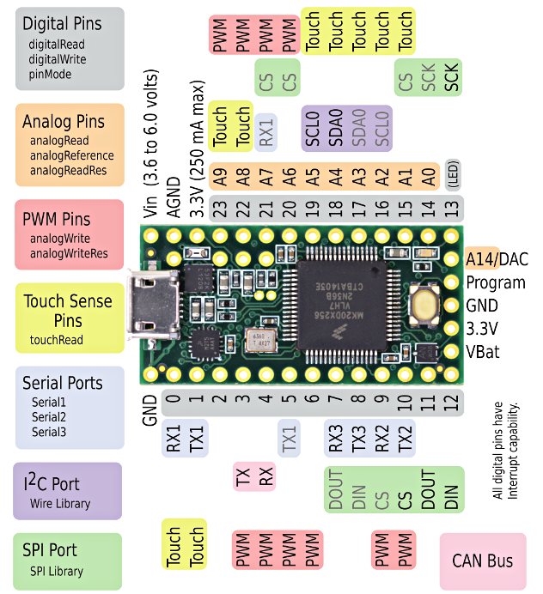Main:

|  |  |  |
| --- | --- | --- |
| PCB Board |  | Teensy Pinout |
| 1 | EN | 4 |
| 2 | S0 | 12 |
| 3 | S1 | 11 |
| 4 | S2 | 10 |
| 5 | S3 | 9 |
| 6 | S4 | A0 |
| 7 | VCC | 3.3 V |
| 8 | GND | GND |

Auxiliary:

|  |  |  |
| --- | --- | --- |
| PCB Board |  | Teensy Pinout |
| 1 | S0 | 8 |
| 2 | S1 | 7 |
| 3 | S2 | 6 |
| 4 | S3 | 5 |

**Teensy Breakout Board:**

|  |  |
| --- | --- |
| Breakout Board | Teensy Pinout |
| 1 | 3.3V |
| 2 | GND |
| 3 | GND |
| 4 | A0 |
| 5 | 4 |
| 6 | 5 |
| 7 | 6 |
| 8 | 7 |
| 9 | 8 |
| 10 | 9 |
| 11 | 10 |
| 12 | 11 |
| 13 | 12 |

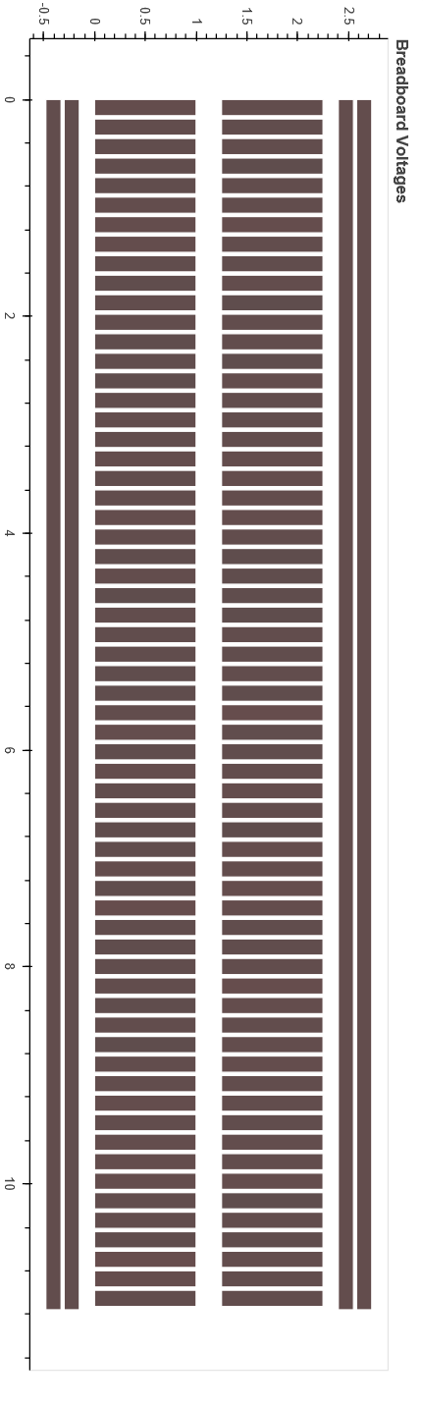

Left column: 0-61

Left NEG rail: 62

Left POS rail: 63

Right column: 64-125

Right NEG rail: 127

Right POS rail: 126

**Format to control:** (strings)

**Evaluate all nodes:**

all*

**Evaluate a single node with time:**

nodeIndex,samplingRate + “*” + “single”

**Material list:**

|  |  |
| --- | --- |
| Quantity | Item |
| 6 | 6-32x3/8 screw |
| 6 | 6-32x3/4 screw |
| 6 | Standoff. L: 1.25 in, Diameter: 0.25 in |
| 8 | 6-32x1/4 nylon screw |
| 8 | 6-32 nylon hex nut |
| 8 | Nylon standoff. L: 0.75 in, Dia: 0.25 in |
| 256 | Pogo pins |

Acrylic sheet clear – 3.175 mm in thickness

New proposed acrylic sheets size – 2.75 mm